Calm Eye - Eye Strain Manager for Office Workers

Requirements Document + Rapid Prototype

CP317 Spring 2020

Project ID: **CP317-TP05**

**Team Members and Student IDs:**

**Shou Nakano** [**naka2910@mylaurier.ca**](mailto:naka2910@mylaurier.ca) **180372910**

**Connor Hagen** [**hage5650@mylaurier.ca**](mailto:hage5650@mylaurier.ca) **180575650**

**Daniel Kwan** [**kwan9440@mylaurier.ca**](mailto:kwan9440@mylaurier.ca) **180449440**

**Vinuyaa Sivanathan** [**siva9210@mylaurier.ca**](mailto:siva9210@mylaurier.ca) **160709210**

**Hai Phan Thanh** [**phan8640@mylaurier.ca**](mailto:phan8640@mylaurier.ca) **180708640**

**Yuki Chen** [**chen8968@mylaurier.ca**](mailto:chen8968@mylauier.ca) **160989680**

Project Specifications Document

**1. Introduction**

**1.1 Purpose of Document:**

This document is intended to establish deliverables agreed upon between the client, Manulife Financial Corporation, and the developer team. This specification document will outline a new web-based application to customize user display and log screen time on Google Chrome built for Manulife Financial Corporation. The Area Vice President(AVP) of the Market Research department has requested a tool to alleviate eye strain of employees who complete the majority of their job responsibilities on the web.

**1.2 Intended Audience:**

The software’s intended audience is the employees of Manulife, specifically the Market Research department. The user’s default browser is Google Chrome which is used daily to complete responsibilities. If the AVP chooses to make the software open source, the audience will expand to Chrome users outside of Manulife ranging from students to the elderly making it available on the Google Store.

**1.3 Intended Use**

The Market Research department predominantly uses the web to collect research in order to complete pertaining analysis. Thus, the main intended use is to manage the color, brightness, and contrast ratio of the website in order to browse the website comfortably and improve the user experience during the research and analysis components of the users’ day.. This will include two elemental color themes: dark and blue light filtering mode set to the user’s preference.

**1.4 Scope**

The scope of the project is a fully functional web-based application that allows employees to relieve eye strain associated with prolonged exposure to digital screens supporting employees’ workplace wellbeing. In addition, a database containing user settings is expected to be implemented. Issues in regards to website security will be considered and will be a key component within this project to ensure integrity of the software and personal data. The software will ensure no personal data is collected nor browsing history.

**1.5 Technical Definitions and Acronyms**

CSS Cascading Style Sheet: the type of formatting used for layouts of documents displayed on web browsers

HTML Hypertext Markup Language: markup language used to design documents (pages) displayed on web browsers

**2. Overall Description**

**2.1 User needs**

In accordance with our preliminary analysis of the business requirements, the users of this application should be able to modify their web-browsing experience for greater physical comfort. With the majority of web pages accessed daily at Manulife containing white backgrounds on black text, employees at Manulife have identified an area of concern in industrial ergonomics in the office setting. Eye strain from prolonged exposure to computer video terminals has been a common complaint from over 80% of users, according to a study conducted by Optometry 2016 (M. Rosenfield, 2016), and the preliminary analysis of the users at Manulife indeed indicate a similar result. Users of Manulife would like the ability for their default, company-issued web browser (Google Chrome) to assist in managing eye strain in the office. Furthermore, users should have customizability in this aspect, as a change in page background is not warranted for all websites (such as sites with mission-critical tasks, where changing the elements of page backgrounds client-side is ill-advised or against company policy and could result in a human error). Users must be able to turn off the accessibility tool, when required. Some users use glasses or other accessibility aids, and must be able to modify the strength/transparency of the background colour changes, and the colour of such change to suit their needs. Accessibility is the main concern in these cases, and the application must provide sufficient control to the end-user to improve their health and well-being.

**2.2 Actors**

There are 3 actors which will interact with this software, which are stated below.

1. **Google Chrome:** Since the extension will be running on Google Chrome, it’s natural that Google Chrome will be interacting with the software in order to pull data from it in order to update websites’ CSS/HTML code, especially when it comes to their colors. The extension will always be running on Google Chrome, which confirms its relationship with the browser.
2. **End-User:** The extension must be turned on and off by an end-user, who will also be able to adjust various parameters of the extension, such as being able to customize the website’s colors, toggle the extension and change how light/dark they’d like for the website to be. It should also be noted that the end-user creates an instance of the software by downloading it onto Google Chrome.
3. **Website:** The website will interact with the software as well, as its CSS/HTML code will be affected by the extension. Not only that, certain websites will need specific adjustments for the sake of user experience as it will be impossible to automatically adjust the website’s colors using an algorithm without harming the user’s experience. In order to find out if a website will need specific, pre-coded adjustments, the website will have to provide information to the extension, thus, it’s an actor.

**2.2 Assumptions**

There are two primary assumptions within this project:

1. Human Resource Availability: To complete this project, it is assumed that team members are available for the project duration and have all necessary skills to complete this project.
2. Scope Variability: It is assumed that the scope will not change. However, if the project’s scope is modified, a formal documentation is required.
3. Client Feedback: It is assumed that client feedback will be received within two days.

**2.3 Dependencies**

In terms of internal dependencies, status use cases must be implemented before enable and disable use cases are implemented. For example, dark mode status use cases must be created before the dark mode toggle functionality is implemented. Subsequently, page exemptions can be implemented. Otherwise, there are no dependencies and the remaining use cases can be created independently of one another. A key external dependency is on the client as the project follows an iterative process development. Each iteration will require feedback regarding the latest software development; this is crucial to deliver a client satisfactory software. The start of the next iteration will depend on the client feedback from the current iteration. If needed, the client and team can accordingly redefine the requirements of the project, re-estimate budgets and completion dates. Otherwise, no dependencies exist within this project.

**3. System Features and Requirements:**

**3.1 Functional Requirements**

**3.1.1 Use Cases & Descriptions**

1. **Turn on Dark Mode: (*High Priority*)**

*Brief Description:* The ‘Turn on Dark Mode’ use case enables the end-user to turn on dark mode and change the colors of the website that they’re using.

*Step by Step Description:*

1. Determine if Dark Mode is on or off using the ‘Dark Mode Status’ use case.
2. If Dark Mode is on, then do nothing.
3. However, if Dark Mode is off, then turn it on by checking to see if there’s any special code written for this website. If not, change the colors of the website to their dark mode variant by using the extension’s algorithm and overriding the website’s CSS.
4. **Turn off Dark Mode: (*High Priority*)**

*Brief Description:* The ‘Turn off Dark Mode’ use case enables the end-user to turn off dark mode and change the colors of the website that they’re using.

*Step by Step Description:*

1. Determine if Dark Mode is on or off using the ‘Dark Mode Status’ use case.
2. If Dark Mode is off, then do nothing.
3. However, if Dark Mode is on, then turn it off by reverting the HTML of the website to its initial state by removing the CSS override.
4. **Dark Mode Status: (*High Priority*)**

*Brief Description:* Chrome will check the Chrome Extension in order to find out if Dark Mode is currently on or off.

*Step by Step Description:*

1. Chrome submits a request to Calm Eye to check if Dark Mode is on or off.
2. Calm Eye returns this request to Chrome, which is then returned to the algorithm.
3. **Change the Color of the Website: (*High Priority*)**

*Brief Description:* The ‘Change the Color of the Website’ use case enables the end-user to select a different color for the website’s background.

*Step by Step Description:*

1. Take the color that the end-user has chosen as input.
2. Adjust the background of the website to the input.
3. **Change the Page Element - Brightness Slider: (*Medium Priority*)**

*Brief Description:* In some cases, the user might want the page elements on their website to be brighter and the website to be even darker. In this case, the ‘Change the Page Element Differentiation of the Website’ use case will make the page elements brighter or darker depending on the end-user’s input.

*Step by Step Description:*

1. Take the numerical value that the end-user has chosen as input for this use case, which will be input using a slider.
2. Then, take the CSS code and amplify the colors by using the numerical value as a parameter to properly amplify or deamplify the page elements’ differentiation.
3. **Page Exemptions (*Medium Priority*)**

*Brief Description:* Users will be able to disable the extension from running on certain web-pages to increase user experience.

*Step by Step Description:*

1. Add a web domain or page to the list where the extension will be disabled from running.
2. Reload website to reflect changes and keep record of user preference
3. When a page load occurs, the software will verify if the user has disabled the extension on the web page or domain.
4. **Contrast Slider (*Low Priority*)**

*Brief Description:* Users will be able to adjust the contrast shown by a slider.

*Step by Step Description:*

1. User will be able to click +/- buttons to choose preferred display of contrast

**3.1.2 Use Case Diagram**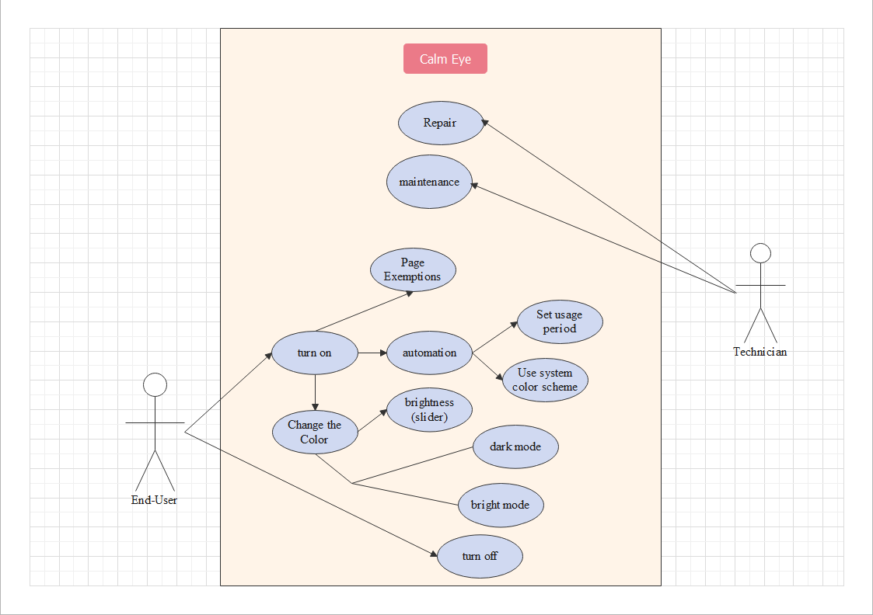

**3.2 External Interface Requirements**

1. **Product Logo (*High Priority*)**

*Brief Description:* A product logo is created with simple and clean design using the colour palette selected by Manulife.

1. **Menu Page (*High Priority*)**

*Brief Description:* Menu Page will include the following three buttons: Home, Change Colour and Options.

1. **Home Button: (*Medium Priority*)**

*Brief Description:* The home button will direct the user to a website with extension information. However, this button may be subject to change.

1. **Change Colour Button: (*High Priority*)**

*Brief Description:* The change colour button will direct users to display setting options which are listed below.

* 1. Dark Mode Toggle *(High Priority*)
  2. Blue Light Filter Mode Toggle *(Medium Priority*)

1. **Options Button: (*Medium Priority*)**

*Brief Description:* The options button will direct the user to additional settings.

* 1. Page Exemptions *(Medium Priority*)
  2. Help Tools *(Medium Priority*)

1. **Brightness Slider: (*Low Priority*)**

*Brief Description:* The slider will allow the user to increase and decrease brightness.

1. **Contrast Slider: (*Low Priority*)**

*Brief Description:* The slider will allow the user to increase and decrease contrast.

1. **Colour Theme: (*High Priority*)**

*Brief Description:*  The software will be designed with the following colours selected by Manulife.

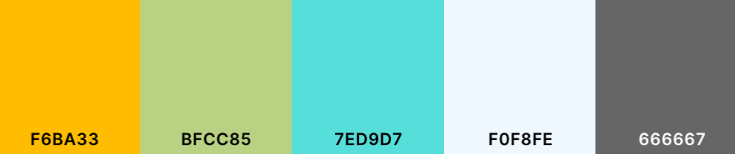

**3.3 System Features (Search up Features VS Functionality).**

In order to ensure that the extension is easy to use by the end-user, several features will be implemented into the extension. By default, it’ll be easy to access through a button on the top right corner of the user’s browser, with a toggleable button that will tell the user whether the website’s in its’ normal mode or its’ dark mode. The contrast and page-element brightness sliders will be implemented in an easy to use format as the user will be able to easily interact with both of them to adjust the page to their liking. Since we’ll only be adjusting the colors on the webpage and searching for exceptions in the case of certain websites, the user should expect immediate service, with the page being adjusted within a second. The software is not real-time as the browser will only need to be updated once per page and so, immediate service is not required, but instead, highly recommended.

**3.4 Nonfunctional Requirements**

*No changes documented from Project Proposal*

1. **Database Implementation: (*High Priority*)**

*Brief Description:* A database should be used in order to remember and coordinate user data. Including themes, transparency, or amount of screen time.

1. **Security and Privacy: (*High Priority*)**

*Brief Description:* Security measures must be maintained so that user information will not be used for malicious intent. Must also follow schemas, ensure constraints and preferably create a back up. Capable of reading and writing HTML documents

1. **Enable reading & writing HTML documents Capabilities: (*High Priority*)**

*Brief Description:* Users must allow access for the extension to change website HTML data into their desired preferences. This also includes selecting correct HTML elements and adjusting their values.

1. **End Product Documentation: (*High Priority*)**

*Brief Description:* A detailed documentation will be provided on how to use and troubleshoot the product.

**3.5 Requirements Gantt Chart**

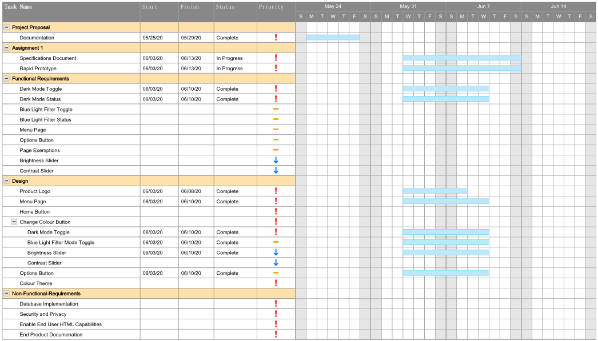

**3.6 Prototype**

See the link below for a video demonstration of the prototype developed for Calm Eye.

<https://drive.google.com/file/d/1uHa8msd7nRnyT_wQDwYHauH-nupdBktA/view?usp=sharing>

**3.7 References**

Rosenfield, Mark. "Computer vision syndrome (aka digital eye strain)." *Optometry* 17.1 (2016): 1-10.

<https://www.researchgate.net/profile/Mark_Rosenfield/publication/295902618_Computer_vision_syndrome_aka_digital_eye_strain/links/56cf685008ae4d8d649fc316.pdf>

**3.8 Work Done by Each Team Member**

Shou Nakano: Actors, Use Cases/Descriptions, System Features

Connor Hagen: User Needs, Prototype Assistance, Prototype Demonstration

Daniel Kwan: Rapid Prototype

Vinuyaa Sivanathan: Introduction, Requirements Gantt Chart, External Interface Requirements, Nonfunctional Requirements

Hai Phan Thanh: Implementation Ideas, System Features, Reviewing

Yuki Chen: Use Case Diagram

**3.9 Declaration**

This is a declaration that all team members have participated in Survey 2 alongside the submission of this assignment.